
PB9000 4K Over IP
AV Matrix/VideoWall/IP KVM

User Guide

WWW.AAVARA.COM
AAVARA INNOVATION CORP.
ALL RIGHTS RESERVED
Rev 2.0.6

Table of Contents
I. PB9000 models: 3
II. Ethernet Switch Setting 3
III. PB9000 Hardware Installation 3
IV. Integrate with 3rd Party Controller 4
V. User Scenario - Use IR Remote/Dip Switch to Switch Video Channel 5
VI. IP Setting, Web Configuration & Control 6
VI.A. To Know IP address of Aavara HDMI Over IP Sender and Receiver 6
VI.B. Launch AV Master Control Web page 6
VI.C. Change IP address of Sender and Receiver 7
VII. Aavara AV Master Web Interface 8
VII.A. User Login 8
VII.B. Setup within AV Master Web Interface 10
VII.C. Setup & Backup by CSV files 12
VII.D. Device IR Command Learning 19
VII.E. Multicast 20
VII.F. Matrix 20
VII.G. Multicast Group 21
VII.H. Click Apply ButtonVideoWall Setup 22
VII.I. VideoWall 23
VII.J. Control 24
VII.K. EDID Manager (Only Available on Sender) 25
VII.L. User Management 27

Information in this document is subject to change without notice.

© 2021 Aavara Innovation Corp. All rights reserved.
Reproduction in any manner whatsoever without the written permission of Aavara Innovation Corp. is strictly forbidden.
Trademarks used in this text: Aavara, the Aavara logo and Aavara AV Master are trademarks of Aavara Innovation Corp.
Other trademarks and trade names may be used in this document to refer to either the entities claiming the marks and names or their products. Aavara Innovation Corp. disclaims any proprietary interest in trademarks and trade names other than its own.

PB9000 models:
Model | PB9000-SE+ | PB9000W-SE | PB9000HD-SE | PB9000-R
Sender/Receiver | 4K Sender | EU Wall-Plate  Sender | 1080p Sender | Receiver
Max. Video Format | 4K60Hz 4:2:0 Input | 4K60Hz 4:2:0 Input | 1080p60Hz 4:4:4 Input | 4K30Hz 4:4:4 Output
Max. Audio Format | 7.2 ch LPCM/Dolby ATMOS/DTS X
Video Connector | HDMI/VGA Input, HDMI Loop out | HDMI/VGA Input | HDMI/VGA Input, VGA Loop out | HDMI/VGA Output
Audio Connector | 3.6mm Line In/Line Out, S/PDIF Optical Out | 3.6mm Line In/Line Out | 3.6mm Line In/Line Out | 3.6mm Line In/Speaker Out
RS232 Connector | DB15 x 1 | DB15 x 1 | DB15 x 1 | DB15 x 1
IR Connector | IR Emitter Jack x 1  IR Receiver Jack x1 | IR Emitter Jack x 1  IR Receiver Jack x1 | IR Emitter Jack x 1  IR Receiver Jack x1 | IR Emitter Jack x 1  IR Receiver Jack x1
USB Connector | USB Type B x 1 | USB Type B x 1 | USB Type B x 1 | USB Type A x 4

Ethernet Switch Setting
- Please select Layer 2/3 managed/smart switch to work with Aavara 4K Over IP.
- Enable IGMPSnooping (Version 2), and all sender/receivers are in same VLAN group.
- Enable JumobFrame (at least 8Kb) on all ethernet switches.
- Enable IGMP Querier on major switch and disable Fast Leave on all switches, If multiple ethernet switches installed.
If be sure network bandwidth between switches enough for video network, can use Fiber connection or set 802.3ad Port Trunking/Link Aggregation to increase bandwidth between switches.
- If Ethernet switch is also use for other service like PC network or Voice Over IP:
- Set different VLAN groups to divide different network service.
- For RJ45 ports or Fiber ports used for other services, set IGMP Blocked (HP switch) or Multicast Forward Forbidden (Cisco switch), to avoid video streaming data affect.
- Be sure save above setting before reboot ethernet switch.

PB9000 Hardware Installation
- Connect all Senders and Receivers to Gigabit Switch by Cat5e/6 cables, and connect to video source and TV/Display with HDMI cables.
- [optional] Connect IR emitter cables & IR Receiver cables to Sender/Receiver's IR Emitter/Receiver Jack. IR emitter cable to IR emitter jack, IR receiver cable to IR receiver jack. And, point IR emitter head of IR emitter cable to device IR receiver window, IR receiver head of IR receiver cable to IR remote location and keep clear line of sight in between.
- [optional] Connect RS232 cables between PC/controller to Senders, TV/Displays to Receivers.
- [optional] Connect USB cables between PC/server to Senders, and plug USB Keyboard/Mouse or other USB devices to Receiver's USB port.
- Plug-in DC power adapter to all Senders and Receivers. Units power on.
If PoE switch or PoE injector connected, then no need to plug-in DC power adapter.
- Power on all Video Sources and start playing video.

Integrate with 3rd Party Controller

PB9000 support following major 3rd party controllers integration:
- Control 4, AMX, Crestron, Extron, RTI, Elan g!, QSC, Neets and more.
Aavara provide controller driver allow 3rd part controller can control Aavara HDMI Over IP sender and receiver by IP command directly.
Please check Aavara representative or your distributor for 3rd party driver and user instruction.

User Scenario - Use IR Remote/Dip Switch to Switch Video Channel

Use Aavara 16 channel IR remote (Optional accessory) /Dip Switch control to control PB9000-RE receiver to switch video channel. User can also use a 3rd party universal IR remote to learn from Aavara IR remote’s IR code and video source IR remote code for controlling both devices by one remote.
- To config Sender Video Channel Dip switch, at front bezel, to a Unique video channel configuration as following table. Recommend to start from video channel 1 then follow the sequence on every sender. Reboot sender for new video channel setting take effect.
- [Must] Plug-in IR receiver cable to PB9000-RE receiver IR receiver jack and toward to IR remote location with clear line of sight.
- [optional] Plug-in IR emitter cable to PB9000-SE sender IR Emitter jack and toward to video source device IR receiver window if need IR control from TV/Display side.
- Use IR remote of PB9000-RE or use 3rd party universal remote control (preconfigured with PB9000-RE IR remote), toward IR receiver which connected to PB9000-RE IR.

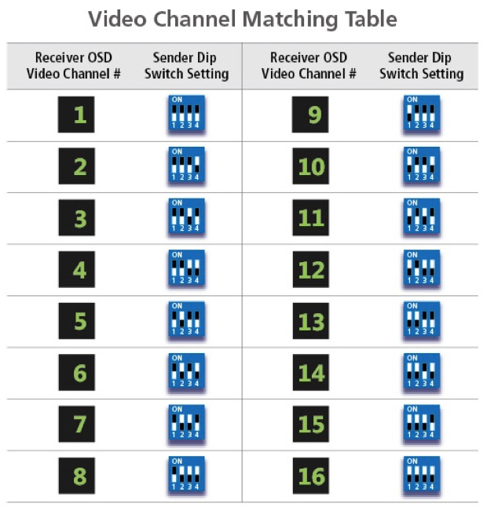
Notice:
Maximum 16 video channels / sender / video sources allow at this scenario, number of TV/Displays is almost unlimited.
IR remote control way is not compatible with Aavara AV Master Web Interface and 3rd party controller control, please don’t mix use other control ways.
Once use Web interface Setup then Dip Switch setting will be ignore!

IP Setting, Web Configuration & Control

To Know IP address of Aavara HDMI Over IP Sender and Receiver
Aavara HDMI Over IP sender and receiver got factory default IP within 169.254.xxx.xxx C class range, and netmask 255.255.0.0, IP address of each HDMI Over IP unit can be found by following way:
Unit IP Show On Screen OSD:
- To set up a sender connect to a receiver by Cat5e cables (can be with or without Ethernet switch in between).
- receiver connect to a TV or Display with a HDMI cable.
- Power on Sender, Receiver and TV/Display.
- On right bottom of screen, it will show:
- Local IP Receiver IP address
- Remote IP Sender IP address
- Then, please connect the sender to a PC/Notebook RJ45 port with a Cat5e cable. And, power on.
- To set PC/Notebook RJ45 port IP configuration as follow:
- IP address: 169.254.0.100 (or any IP within 169.254.xxx.xxx range)
- Netmask: 255.255.0.0
Or
Finding unit and IP in Bonjour Browser
Software Required:
- Apple Bonjour SDK free download from Appple SDK web site, if you are using MS windows OS PC/NB. Apple MacPro or MacBook which don't need it, had built-in OS X.
- can download from Apple developer web site
- Bonjour Browser for easy find out all senders and receivers on network.
- Just google and download from Internet

1. To set PC/Notebook RJ45 port IP configuration as follow:
- IP address: 169.254.0.100 (or any IP within 169.254.xxx.xxx range)
- Netmask: 255.255.0.0
2. Setup all Cat5e cable connection between PC/Notebook, sender, receiver and Ethernet switch, then power on.
3. [optional] Install Apple Bonjour SDK on your MS Windows PC/Notebook.
4. Launch Bonjour Browser and check HTTP service section. All Aavara HDMI Over IP sender and receiver can be found at following domain name:
- Sender Aavara-gateway0000.local 0000 represent video channel number
- Receiver Aavara-clientAAAAAAAAAAAA AAAAAAAAAAAA represent MAC address of receiver

Launch AV Master Control Web page
http://[unit ip]/cfg.html Unit configuration web page (needed only when you want to change unit IP)
http://[unit ip]/index.html Aavara AV Master /Control web page

Change IP address of Sender and Receiver
Aavara HDMI Over IP sender and receiver got factory default IP within 169.254.xxx.xxx C class range, and netmask 255.255.0.0. Recommend to set static IP to each box to know which one is which one on network. IP address of each HDMI Over IP unit can be changed by following way:
1. Launch Web browser with following URL, the Unit Web page will show:
http://[unit ip]/cfg.html
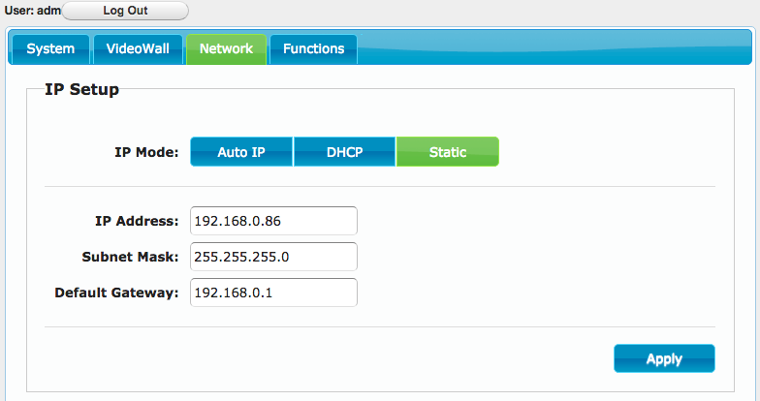
3. Change IP Mode to Static
- IP Address: Please assign a IP with correct format. (Ensure all boxs’ IP are at same C or D class range).
- Subnet Mask: 255.255.0.0 or base on proper ethernet network planning.
- Default Gateway: Only if need, please refer gateway setting on Router.
4. Click Apply Button to save new setting, but unit need to reboot to get new setting effect.
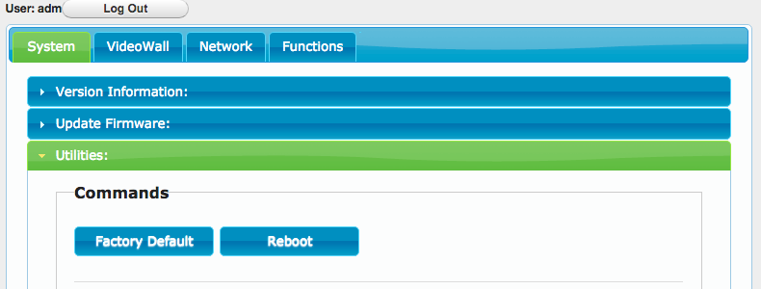
5. Click System Tab → Utilities → Click Reboot button, reboot.

Aavara AV Master Web Interface
Aavara AV Master Web interface, built-in in every Aavara HDMI Over IP unit, is a one web page setup and control entire HDMI Over IP AV Matrix and Video Wall. It will only need to configure and operate Aavara AV Master Web Interface on One unit then that unit will become master control unit of entire system, usually recommend to use first sender, then all rest of units just take order.

To Connect Aavara AV Master Web Interface via PC/Tablet connect to same ethernet Switch/Wifi AP with following IP setting:
- IP address: any no conflict IP within same C or D class IP range with all senders and receivers.
- Netmask: 255.255.0.0 or value base network configuration that allow all unites can see each other.
Factory default IP range is 169.254.xxx.xxx netmask 255.255.0.0
Or, same static IP range had been set on boxes.
- Web browser: recommend Google Chrome, Firefox, Safari

Launch Web browser with following URL (domain name of sender at channel 0, default sender setting):
http://aavara-gateway0000.local

User Login

Every time launch web browser and Aavara AV Master Web page will ask user to login.


System Default Login name and Password (Can be revised or delete later on at User Management Tab) with Administrator authorization.

Login name: adm
Password: adm

After Login, on right top corner will show Login User info and Logout button.

User with Administrator authorization will see both AV Matrix/VideoWall/Control Operation and All Setup functions.

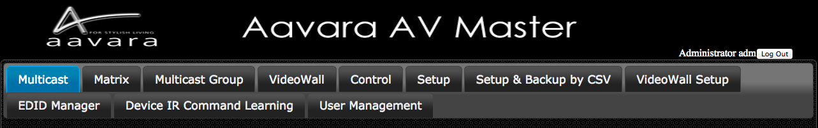
User with Operator authorization will see AV Matrix/VideoWall Operation functions only.

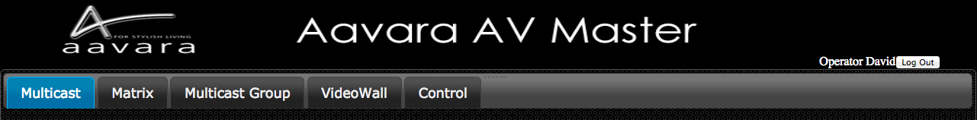
Only User with Administrator Authorization allow to access unit configuration cfg.html

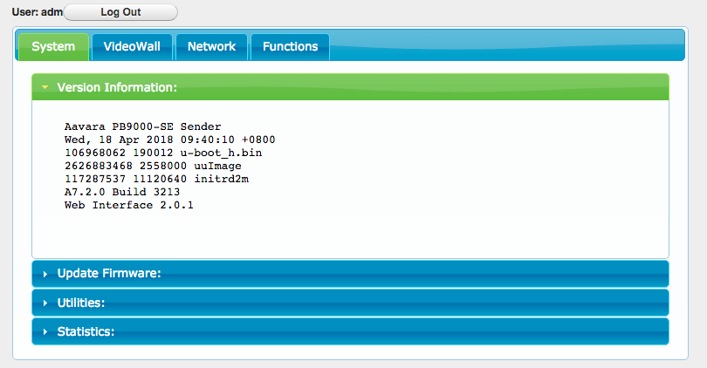
Access other units’ web page other than master control unit, will redirect web page/URL to master control unit’s web page.

Once User Session expired, AV Master Web Interface will ask user to login again.

Setup within AV Master Web Interface

Click on Setup Tab on first time installation and configuration change later on, wait few seconds, AV Master will scan and list all Senders and Receivers. Please configure all parameters for Senders and Receivers, detail at table below, according installation & operation requirement. All settings will storage in this Sender or Receiver only and later on operation shall connect to this Sender/Receiver's web page only.
If any USB or RS232 setting changed, the unit will need to reboot to get new setting effect.
For Device Control Command code setup, need to do by CSV file uploading way as next section show.
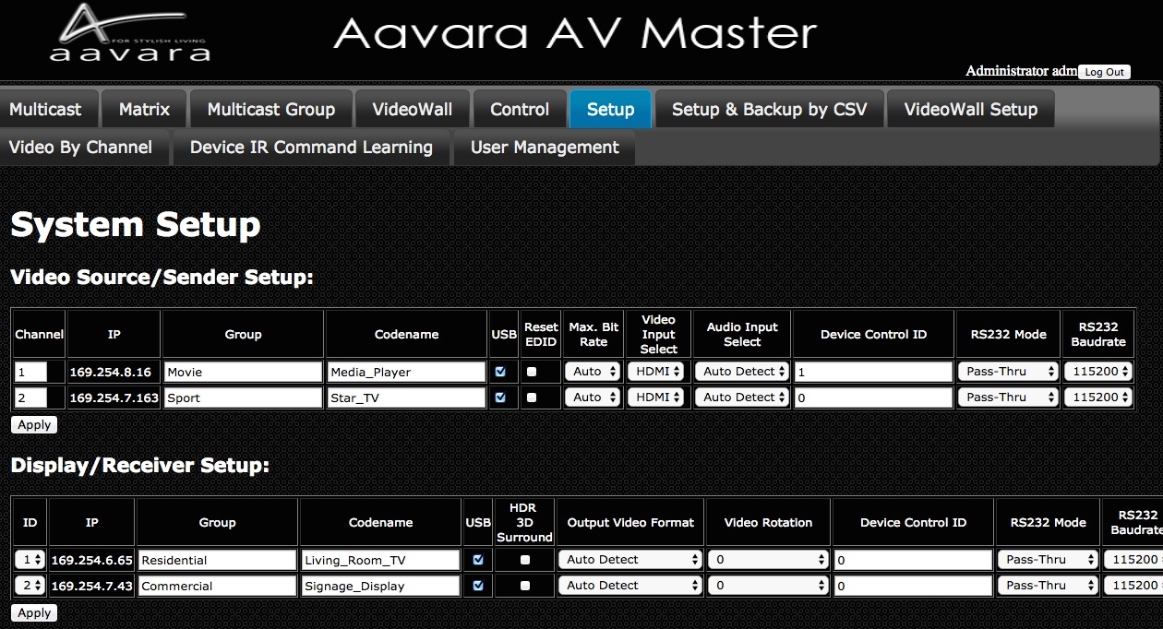
Video Source/Sender:
Field | Description
Channel | Range 1 ~ 9999, Auto assign or manual change, Each sender must have Unique Channel Number assign. No two or more Senders got same channel number.
IP | IP Address (Auto assign, or go Unit cfg.html for static IP assign)
Group | Sender’s Group name for further management requirement.
Codename | Sender’s Codename / Video Source name for further operation required.
USB | Enable (checked) / Disable (unchecked) USB pass-thru
Reset EDID | Reset Sender EDID table to factory default
Max. bit rate | Set Maximum Bit rate on video streaming for bandwidth control  Video quality will drop if choose smaller max. bit rate
Video Input Select | Select HDMI or VGA Input for video streaming
Audio Input Select | Select Audio Source from HDMI or Analog Audio Input
Device Control ID | Match Device ID in Device Control CSV File (control by CEC(HDMI)/IR/RS232)
RS232 Mode | IP Command Rs232 command issue by IP command  Pass-Thru RS232 command pass-thru between sender and receiver rs232 ports
RS232 Baudrate | Assign RS232 Baudrate , range 115,200 ~ 300 bps

Display/Receiver:
Field | Description
ID | Auto or Manual Assign, Each Receiver must have Unique ID Number assign. No two or more Receivers got same ID number.
IP | IP Address (Auto assign, or go Unit cfg.html for static IP assign)
Group | Receiver’s Group name for further management requirement.
Codename | Receiver’s Codename / Display name for further operation required.
USB | Enable (checked) / Disable (uncheck) USB pass-thru
HDR/3D/Surround | Enable (checked) / Disable (uncheck) EDID Copy to support HDR, 3D and Surround Sound output (LPCM/Dolby/DTS)
Video Format | - AutoDetect Auto Detect TV/Display’s EDID and output recommend video format.  - Same as Video Input at Sender side (Pass-Thru)  - Fixed HDMI format 2160p30Hz ~ 576p50Hz, 480p60Hz.  Fixed DVI format 1920x1200@60Hz, 1440x900@60Hz and more.
Video Rotate | Video Rotate 0, 90, 90 stretch, 180, 270 degree, vertical/horizontal mirror
Device Control ID | Match Device ID in Device Control CSV File (control by CEC(HDMI)/IR/RS232)
RS232 Mode | IP Command Rs232 command issue by IP command  Pass-Thru RS232 command pass-thru between sender and receiver rs232 ports
RS232 Baudrate | Assign RS232 Baudrate , range 115,200 ~ 300 bps

Notice!
- Please wait for few sec. AV Master will search all senders and receivers on network.
- Each Sender must be assign a unique video channel (CH) number, NO two senders got same number.
- Group name and Codename can use English, French, Latin, German, Chinese and Japanese fonts, but it won't able to show on OSD. Use underscores instead of spaces for the Group name and Codename fields.
- If USB & RS232 setting changed, the unit will auto reboot to get new settings effect.
- If any of HDMI device connect to Sender or Receiver not support 3D or Multichannel audio, recommend to keep 3D Video & Surround option off to speed up video channel switching and maximum EDID compatibility.

Setup & Backup by CSV files
Setup by CSV Files

- Please set static IP on every each unites, at each units’ cfg.html, refer IP setting section for more detail.
- Login user with Administrator authorization.
- Refer following CSV files detail to plan and edit in Spreadsheet application. Then, save at CSV file format (divide field by a comma.)
- Upload CSV files one by one.
- Press button Updating all other unites. This step will take long time to update if large scale matrix/VideoWall installed, please be patient.
- Reboot all unites after CSV files uploaded and all units updated.

Backup by CSV Files
- Click Backup Current Setting Button. AV Master will collect all setting and convert into CSV files.
Web Page will show Sender/Receiver/Control Download CSV file URLs.
- Click the URL to download current CSV files.

Replace AV Master Master Control Unit
- Get a new unit of sender or receiver.
- Change IP setting to be same as the old Master Control Unit, refer IP setting section for more detail.
- Upload Sender/Receiver/Device Control CSV Files
- The unit is ready to replace the old Master Control Unit.

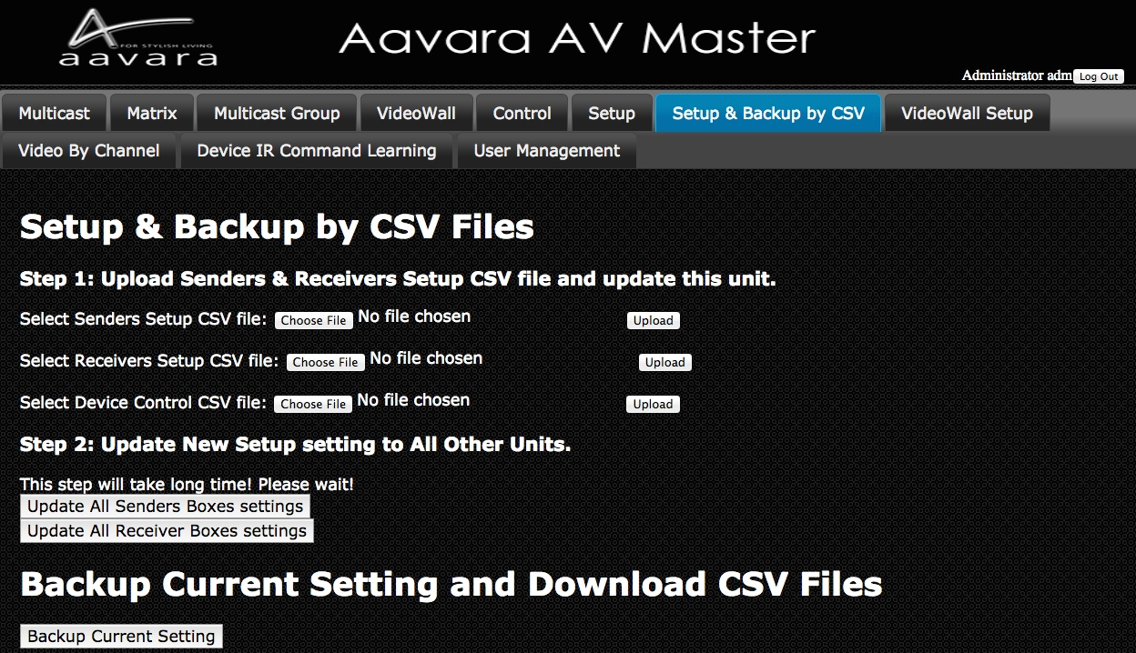
Sender CSV File Format & Parameter Description

Don’t change field sequence. First row field name can be changed. Use comma to divide field when saving CSV file.

Field / Parameter | Description | Parameter Value
IP | Sender IP | ie. 169.254.8.105 192.168.1.25
Channel | Assign unique channel number, don’t duplicate. | 1 ~ 9999
Group | Sender Group name | English, German, French, Latin, Chinese, Japanese, _
Codename | Sender Codename | English, German, French, Latin, Chinese, Japanese, _
Enable/Disable USB Pass-Thru | USB Pass-Thru between Sender and Receiver | y/n only (Lower letters only)  y : disable USB Pass-thru  n : enable USB Pass-thru
Max. Bit Rate | Max. bit rate of video streaming from Sender | Parameter value options:  auto : auto, max. 850Mbps  200M : max.200Mbps  150M : max.150Mbps  100M : max.100Mbps  50M : max. 50Mbps  10M : max. 10Mbps  5M : max. 5Mbps
Video Input Select | Select video input on sender for video streaming | Parameter value options:  0 : VGA  1 : DVI  2 : HDMI
Audio Input Select | Select audio input on sender for audio streaming | Parameter value options:  hdmi : HDMI audio  analog : analog audio  auto : auto select (analog first)
Device Control ID | To match Device ID in Device Control CSV File | Number must be match match Device ID in Device Control CSV File
RS232 mode | IP Command  Pass-Thru between sender and Receiver | Parameter value options:  y : IP Command  n : Pass-Thru
RS232 baudrate | RS232 baudrate setting | Parameter value options:  115200/57600/38400/28800/19200/14400/9600/4800/2400/1200/600/300

Receiver CSV File Format & Parameter Description

Don’t change field sequence. First row field name can be changed. Use comma to divide field when saving CSV file.

Field / Parameter | Description | Parameter Value
IP | Receiver IP | ie. 169.254.8.105 192.168.1.25
ID | Receiver ID, No duplicate | Number only, start form 1
Group | Receiver Group name | English, German, French, Latin, Chinese, Japanese, _
Codename | Receiver Codename | English, German, French, Latin, Chinese, Japanese, _
Video channel | Video channel | Number only, start from 1
Audio channel | Audio channel | Number only, start from 1
Video channel | USB channel | Number only, start from 1
RS232 channel | RS232 channel  (RS232 mode must be set Pass-Thru) | Number only, start from 1
IR channel | IR channel | Number only, start from 1
Output Video Format | Assign Receiver HDMI output video format | Parameter value options:  auto_detect : Auto detect TV/Display EDID  pass-thru : same as HDMI input at sender  0 : same as HDMI input at sender (pass-thru)  2160p30 : 2160p30Hz  2160p25 : 2160p25Hz  2160p24_VIC_103 : 2160p24Hz VIC 103  2160p24_VIC_98 : 2160p24Hz VIC 98  2160p24_VIC_93 : 2160p24Hz VIC 93  1080p60 : 1080p60Hz  1080p50 : 1080p50Hz  1080p24_VIC_72 : 1080p24Hz VIC 72  1080p24_VIC_32 : 1080p24Hz VIC 32  1080i60 : 1080i60Hz  1080i50 : 1080i50Hz  720p60 : 720p60Hz  576p50 : 576p50Hz  480p60 : 480p60Hz  1920x1200 : 1920x1200@60Hz  1920x1080 : 1920x1080@60Hz  1680x1050 : 1680x1050@60Hz  1440x900 : 1440x900@60Hz  1400x1050 : 1440x1050@60Hz  1366x768 : 1366x768@60Hz  800x600 : 800x600@60Hz
Enable/Disable USB Pass-Thru | USB Pass-Thru between Sender and Receiver | y/n only (Lower letters only)  y : disable USB Pass-thru  n : enable USB Pass-thru
Device Control ID | To match Device ID in Device Control CSV File | Number must be match match Device ID in Device Control CSV File
RS232 mode | IP Command  Pass-Thru between sender and Receiver | Parameter value options:  y : IP Command  n : Pass-Thru
RS232 baudrate | RS232 baudrate setting | Parameter value options:  115200/57600/38400/28800/19200/14400/9600/4800/2400/1200/600/300
Video Rotate/Stretch | Video Rotate, Mirror & whether need to stretch when rotate at 90⁰/270^{0.} | Parameter value options:  0 : Not Rotate  1 : Horizontal Mirror  2 : Vertical Mirror  3 : 180⁰ Rotate  4 : 90⁰ Rotate, Vertical Mirror, No Stretch  5 : 90⁰ Rotate, No Stretch  6 : 270⁰ Rotate  7 : 90⁰ Rotate, Vertical Mirror, Stretch  8 : 90⁰ Rotate, Stretch  9 : 270⁰ Rotate, Stretch
vw_row | Total row of VideoWall | Number only, start from 1
vw_column | Total column of VideoWall | Number only, start from 1
vw_pos_row | This Display/Receiver’s row position in VideoWall | Number only, start from 1
vw_pos_column | This Display/Receiver’s column position in VideoWall | Number only, start from 1
vw_OW | Display outter dim. width unit: mm | Number only, start from 1
vw_OH | Display outter dim. height unit: mm | Number only, start from 1
vw_VW | Display viewable area dim. width unit: mm | Number only, start from 1
vw_VH | Display viewable area dim. height unit: mm | Number only, start from 1

Device Control CSV File Format & Parameter Description

Don’t change field sequence. First row field name can be changed. Use comma to divide field when saving CSV file.

Field / Parameter | Description | Parameter Value
Device Control ID | Device Control ID for match with Device Control ID in Sender/Receiver CSV file or Setup Tab in AV Master. | Number Only, start from 1
Codename | Device Codename | English, German, French, Latin, Chinese, Japanese, _
command_type | Way to Control the Device | Parameter value options:  cec : HDMI CEC  ir : IR  rs232_hex : RS232 command in HEX code  rs232_ascii : RS232 command in Ascii code
power_on_name | Power On Command Codename | English, German, French, Latin, Chinese, Japanese, _
power_on_cmd | Power On Command | Base on the way to control, and input control command code.
power_off_name | Power Off Command Codename | English, German, French, Latin, Chinese, Japanese, _
power_off_cmd | Power Off Command | Base on the way to control, and input control command code.
cmd1_name | Command 1 codename | English, German, French, Latin, Chinese, Japanese, _
cmd1_cmd | Command 1 command code | Base on the way to control, and input control command code.
cmd2_name | Command 2 codename | English, German, French, Latin, Chinese, Japanese, _
cmd2_cmd | Command 2 command code | Base on the way to control, and input control command code.
cmd3_name | Command 3 codename | English, German, French, Latin, Chinese, Japanese, _
cmd3_cmd | Command 3 command code | Base on the way to control, and input control command code.
cmd4_name | Command 4 codename | English, German, French, Latin, Chinese, Japanese, _
cmd4_cmd | Command 4 command code | Base on the way to control, and input control command code.
cmd5_name | Command 5 codename | English, German, French, Latin, Chinese, Japanese, _
cmd5_cmd | Command 5 command code | Base on the way to control, and input control command code.
cmd6_name | Command 6 codename | English, German, French, Latin, Chinese, Japanese, _
cmd6_cmd | Command 6 command code | Base on the way to control, and input control command code.
cmd7_name | Command 7 codename | English, German, French, Latin, Chinese, Japanese, _
cmd7_cmd | Command 7 command code | Base on the way to control, and input control command code.
cmd8_name | Command 8 codename | English, German, French, Latin, Chinese, Japanese, _
cmd8_cmd | Command 8 command code | Base on the way to control, and input control command code.
cmd9_name | Command 9 codename | English, German, French, Latin, Chinese, Japanese, _
cmd9_cmd | Command 9 command code | Base on the way to control, and input control command code.
cmd10_name | Command 10 codename | English, German, French, Latin, Chinese, Japanese, _
cmd10_cmd | Command 10 command code | Base on the way to control, and input control command code.

RS232 HEX code format:

HEX code format can be any one of below:

- FF010204
- FF 01 02 04
- 0xFF 0x01 0x02 0x04
- 0XFF 0X01 0X02 0X04

IR HEX code format:
PRONTO HEX format. Please refer Device IR Leaning section for more detail.
CEC Preset Commands and Commands in CEC Frame format

Preset CEC Command List:
Video Source |  | TV/Display
Command | Description | Command | Description
wake_up | Video Source Device Wake UP | power_on_tv | Display Power On
standby | Video Source Device Standby | power_off_tv | Display Power Off
up | Up
down | Down
left | Left
right | Right
select_button | Select
exit | Exit
root_menu | Root Menu
play | Play
stop | Stop
pause | Pause
mute | Mute
volume_up | Volume Up
volume_down | Volume Down

If the command wanted is not in above preset list, you can use CEC Frame in command code field.
CEC Frame format ie. 0F:86:10:00 or FF:36
For CEC Frame detail, please check CEC O Matic web site, http://www.cec-o-matic.com.

Device IR Command Learning

Aavara AV Master Web control can learn Device IR command code, so it can copy n paste into Device Control CSV file.

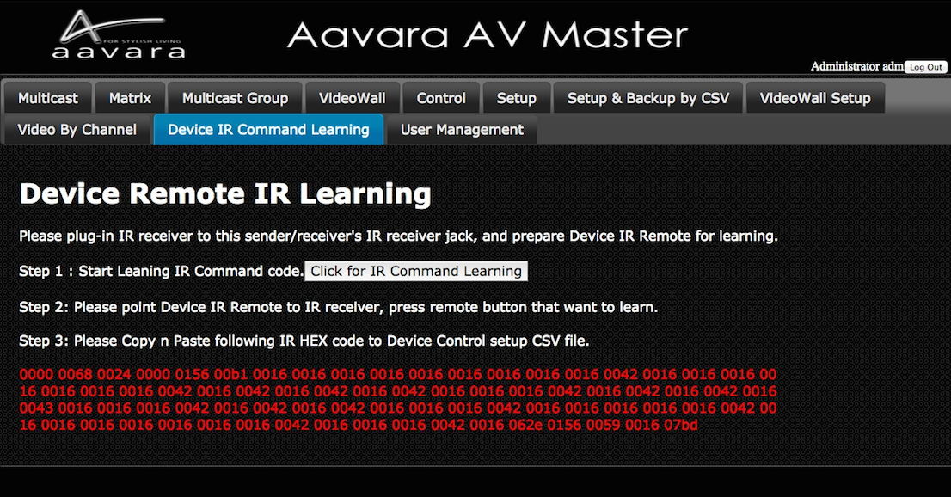
Step 1: Ensure IR Receiver cable had plug into AV Master Master Control unit’s IR Receiver jack. And, have Device IR remote on hand ready for IR code learning.
Step 2: Please point Device IR remote to IR receiver, and press remote button which want to learn IR code from.
Then, IR HEX code (PRONTO format) will show below in red.
Step 3: Copy n Paste IR HEX code (in red) to the cell of Device Control CSV file for further upload and operation.

Multicast
- Select a video source/sender.
- Select Service want to switch (Audio, Video, IR, RS232, USB. Multiple choices).
- Select Display/Receiver want to switch (Multiple choices).
- Click Apply Button

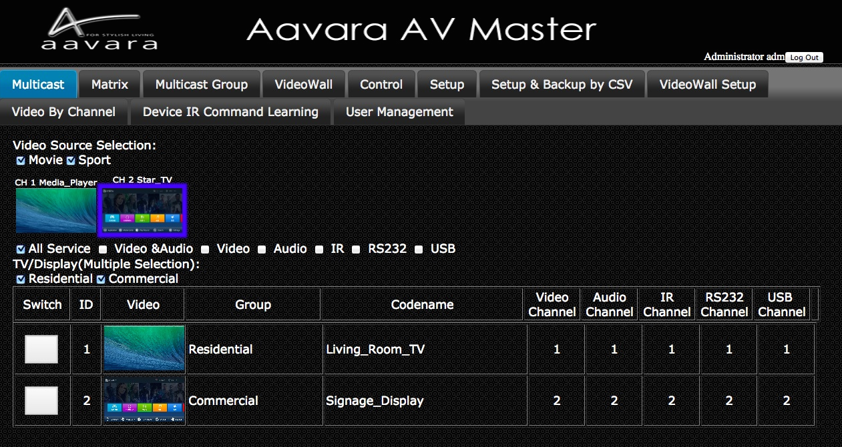
Matrix
- Select Service want to switch (Audio, Video, IR, RS232, or USB).
Once Select Service want to switch, Matrix will refresh to show current routing status.
- Click Switch Button on the cell match the row of Receiver want to switch and the column of target Sender.
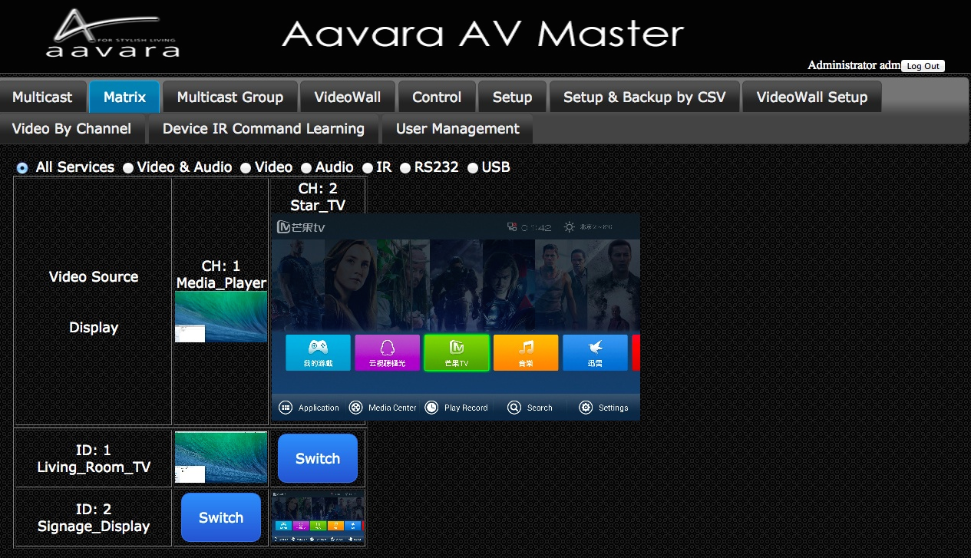

Multicast Group
- Select a video source/sender.
- Select Service want to switch (Audio, Video, IR, RS232, USB. Multiple choices).
- Select Receiver Group want to switch (Multiple choices).
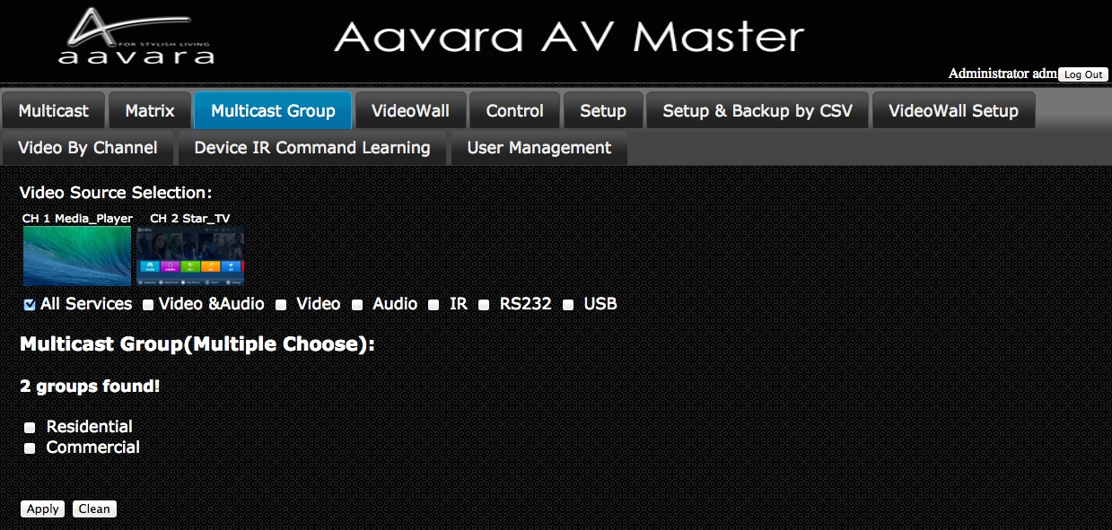

Click Apply ButtonVideoWall Setup
Step 1 VideoWall Layout / Bezel & Gap Compensation
1. Select VideoWall layout from 2x2, 3x3, 3x4, 4x4, ..., 9x9.
2. Input Outer and Viewable area dimension of display for Bezel & Gap compensation. Unit: mm.
Step 2 Display Position at VideoWall Matching
Once Click on Apply Button of VideoWall layout configuration, a table will show up as VideoWall layout, select right receiver in every cell of table which matched row and column display actual position. For position on VideoWall has no display, select N/A.
After all displays/receivers in video wall being located, Click Apply button.
ViewWall Tab will change base on VideoWall layout input and ready to operate.

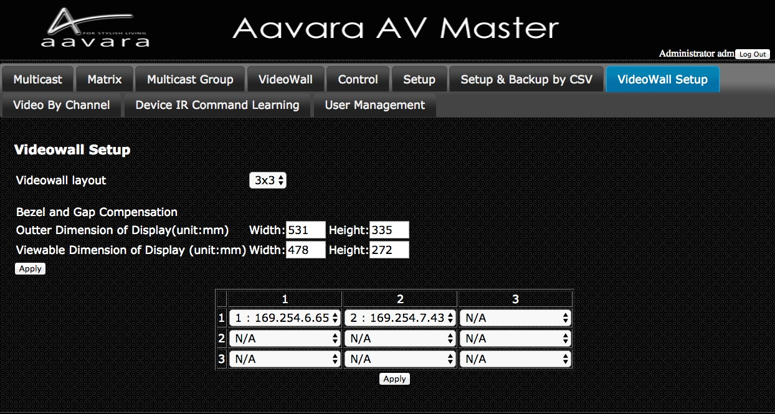

VideoWall
Once ViewWall Setup completed in VW Setup Tab, VideoWall Tab will show right VideoWall layout selection.
1. Select one of VideoWall Zone Layout selection at left column of table.
Left cell of Table will show the VideoWall ZoneLayout selected.
2. Click one of snapshot image of Video channel at top row, and drag to the VideoWall zone want to show.
VideoWall will show layout and video channel you selected.

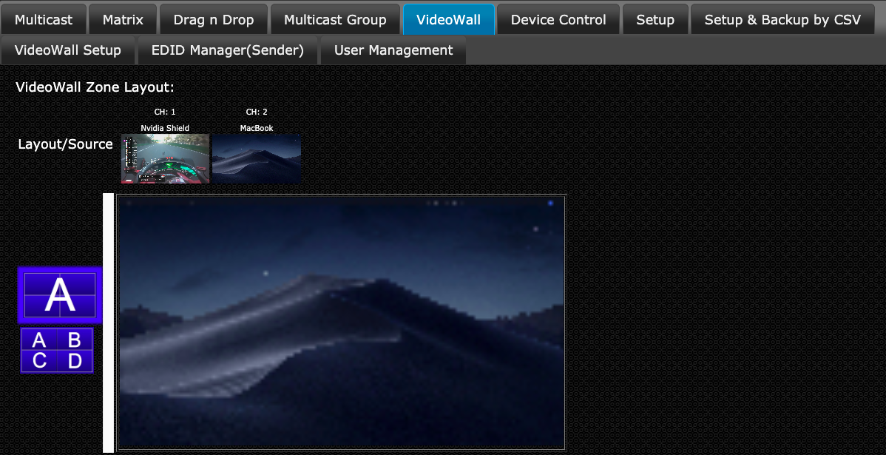

Control

Aavara AV Master Web can control external devices like TV/Display/Projector & Video Source Device by CEC(via HDMI connection), RS232 and IR. Please edit and upload Device Control CSV file and set Device Control ID to each sender and receiver, AV Master will bring in all control command buttons of that device.

Click on the button of control action wanted, control command will send out to target external device immediately.

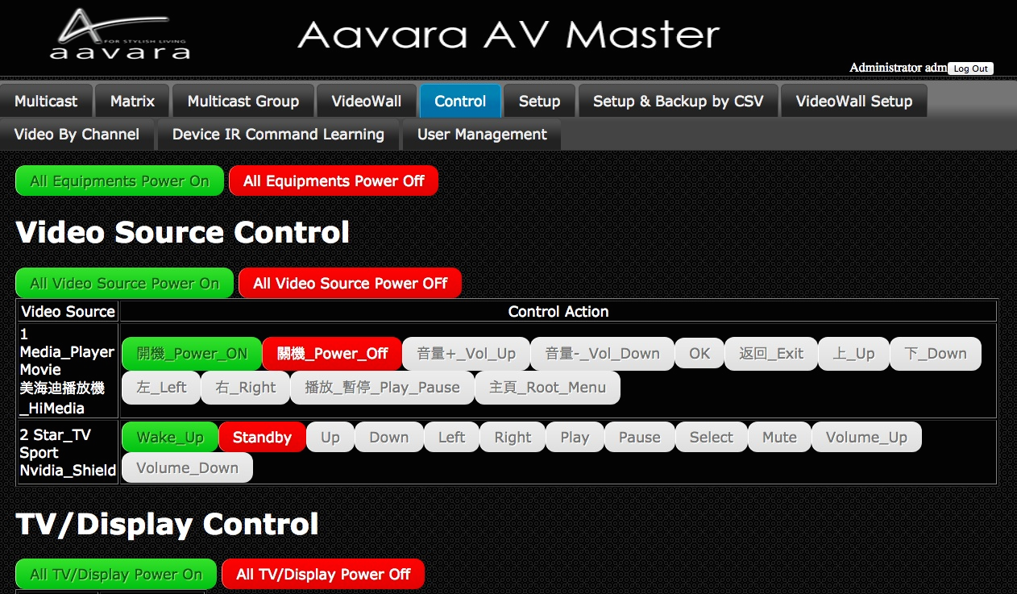

EDID Manager (Only Available on Sender)

Copy Display EDID to Sender
Ensure that target display/receiver got HDMI connection between display and receiver, network connection between sender and receiver, and sender/receiver at same video channel, before Copy Display EDID to sender action.
- To improve EDID compatibility, add HDR and multi-channel audio support, options as follow:
- Copy Display EDID w/o any change (Default)
- Video no change, All Audio Formats
- 2160p60 HDR w/ All Audio Formats
- 2160p60 HDR Audio format no change
- 2160p24 HDR w/ All Audio Formats
- 2160p24 HDR Audio format no change
- 1080p HDR w/ All Audio Formats
- 1080p HDR Audio format no change
- Select Display/Receiver like to copy EDID from
- Click Apply button
- Display EDID will be copy, send to sender at same channel with receiver, and save at sender. Sender will use this EDID to do EDID handshake with Video Source Device.

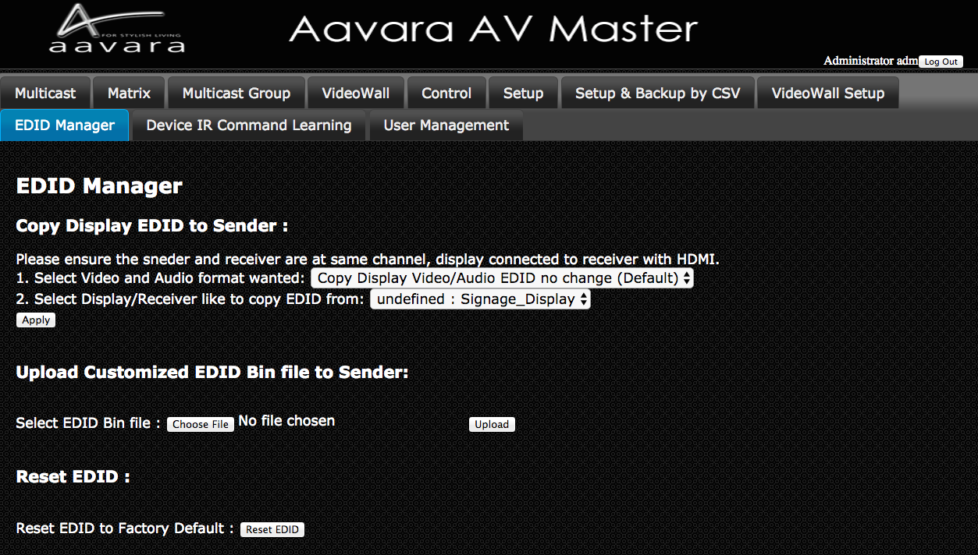
Assign Specific Resolution/Timing EDID to Sender
Select and assign Specific Resolution/Timing EDID to Sender for handshake with Video Source device for solving EDID compatible issue or allow video source output video/audio format as assigned.
1. Select Video Format
2. click Apply Button
3. Recommend to have HDMI unplug n plug-in between video source and sender for good EDID handshake.
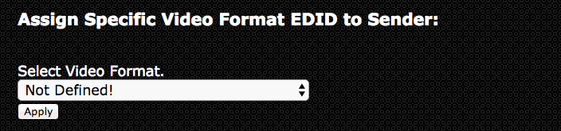
Upload Customized EDID Bin file to SenderEdit customize EDID Bin with EDID editor(not included), then upload to sender. Sender will use customized EDID table to handshake with Video Source device for solving EDID compatible issue or allow video source output video/audio format as assigned.
1. SIs and Installers can use any EDID edit software to customize EDID table and save as standard EDID BIN file.
2. Go EDID MGR tab.
3. select customized EDID bin file and Click Upload button.
4. Once Customize EDID BIN file upload complete, please check the HEX code of EDID used whether it changed and same as customize EDID table.

Reset EDID to default
Just click on Reset EDID to Default Button, then Sender EDID table with reset to default one.

Download Current EDID
Just click on Reset EDID to Default Button, then Sender EDID table with reset to default one.

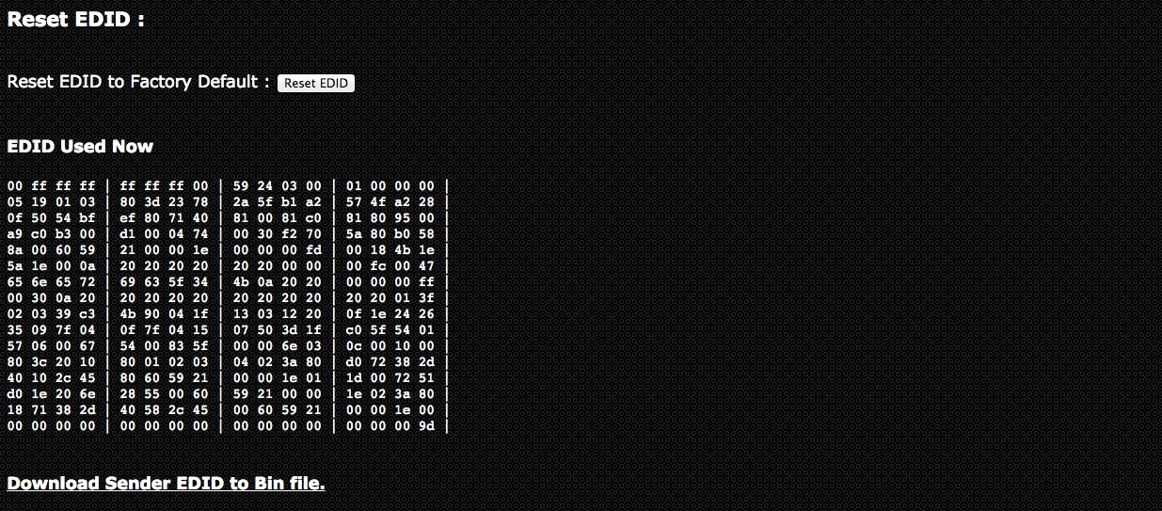

User Management

User Management Tab

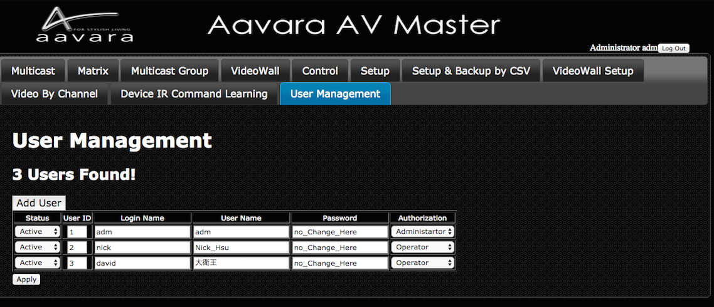
Add User
Press Add User button to add more user info.

Field | Description
Status | 3 User Status:  1. Active this user can login and use.  2. Suspend this user can’t login and use, but user info will keep in system.  3. Delete Delete this user, and user info will erase.
User ID | Every User need to assign a ID, no duplicate.
Login Name | Use for login, English and number letters only.
User Name | Use for identify user. Can use English, German, French, Latin, Chinese, Japanese, _
Password | User Password, English & number only.  Once real password input and updated, it will not show on web again.  Every time User Management table refresh, it will show “no_Change_Here”.  As long as “no_Change_Here” not change, password will not change.
Authorization | Two User Authorization:  - Administrator can access all operation and setup functions.  - Operator can access all operation functions only.

Notice! If many senders and receivers installed, once click Apply button, user info updating will take some time, please wait for user info update completed.

